**Name: Adarsh Samani**

**Branch: Computer Engineering**

**Procedure of Case Study:**

**1)** I built a delivery assignment system using Java in VS Code that allocates food orders to available drivers based on their availability.  
**2)** I used a PriorityQueue to always pick the driver who gets free the earliest, ensuring optimized delivery scheduling.  
**3)** Each order assignment or failure is displayed in the console and also stored in a MySQL database using JDBC.  
**4)** The database (loginext) and table (orders) were set up using MySQL Workbench, and I connected using the MySQL connector JAR.  
**5)** This project demonstrates real-time decision-making, clean code structure, and full database integration.

**Commands used to run the code:**



**Input:**

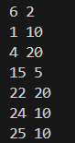

**SQL Scripts:**

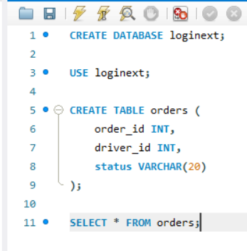

**Output:**



